

CSA0653 - DAA for Complex Problem
Slot C (Hosteller)
CO4-ASSIGNMENT 2 INDUSTRY PROBLEM SOLVING TASK

NAME : Saimeera D
REG NO : 192524405

1.Warehouse Delivery Route Optimization Using Greedy Strategy
Problem Statement
A logistics company has a fleet of delivery vehicles that must deliver packages to multiple locations. Each route between locations has a different transportation cost. The company wants to find a route network with minimum total cost using a Greedy Strategy.
This problem can be modeled as a Graph:
- Vertices (Nodes): Warehouse and delivery locations.
- Edges: Routes connecting locations.
- Weight: Cost or distance of the route.

Graph Model
Example:
A
/ \
10 15
/ \
Warehouse----B
\ /
20 25
\ /
C
Route | Cost
W-A | 10
W-B | 20
A-B | 15
A-C | 25
B-C | 30

Appropriate Greedy Algorithm
Minimum Spanning Tree (MST)
An MST connects all locations with:
- Minimum total cost
- No cycles
- Exactly (V − 1) edges
Two Greedy Algorithms:
1. Prim's Algorithm
- Starts from any node.
- Repeatedly selects the minimum cost edge connecting a visited node to an unvisited node.
2. Kruskal's Algorithm
- Sort all edges by cost.
- Repeatedly select the smallest edge that does not create a cycle.

How Prim's Algorithm Selects Routes
Example:
Warehouse--10--A
Warehouse--20--B
A--------15--B
A--------25--C
B--------30--C
Step 1:
Choose W-A (10)
Step 2:
Choose A-B (15)
Step 3:
Choose A-C (25)
MST:
Warehouse--10--A
|
15
|
B
|
25
|
C
Total Cost:
10 + 15 + 25 = 50

Advantages
Greedy Strategy
- Easy to implement
- Fast execution
- Works well for large logistics networks
MST
- Minimum infrastructure cost
- Eliminates unnecessary routes
- Reduces transportation expenses

Disadvantages
Prim's Algorithm
- Requires connected graph
- Does not provide shortest delivery path
Kruskal's Algorithm
- Sorting edges increases computation
- Not suitable for disconnected networks

Time Complexity
Prim's Algorithm
Using Adjacency Matrix:
Time Complexity = O(V²)
Space Complexity = O(V²)

Using Priority Queue:
Time Complexity = O(E log V)
Space Complexity = O(V + E)

Kruskal's Algorithm
Sorting Edges = O(E log E)
Union-Find Operations = O(E)
Overall Complexity = O(E log E)
Space Complexity = O(V)

Python Program (Prim's Algorithm)
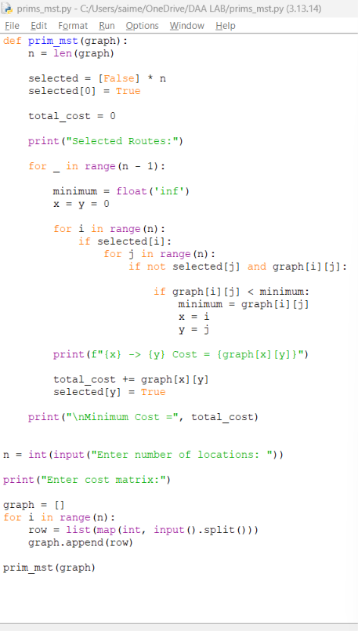

Sample Input
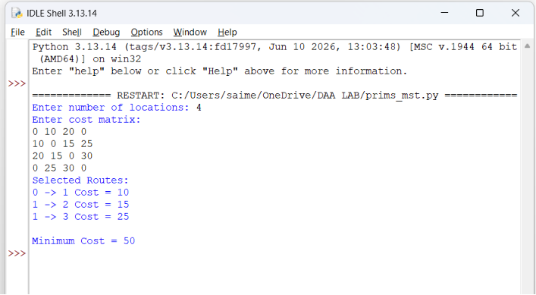

Conclusion
For warehouse delivery route optimization, the network is modeled as a weighted graph. Using the Greedy Strategy, Prim's Algorithm or Kruskal's Algorithm can construct a Minimum Spanning Tree (MST) that connects all delivery locations with the minimum total transportation cost. This helps logistics companies reduce operational expenses and improve route planning efficiency.

Manufacturing Resource Allocation Using Dynamic Programming
1. Problem Formulation as an Optimization Problem
Given a budget of ₹100,000 and four products:
Product | Investment (₹) | Profit (₹)
A | 20,000 | 25,000
B | 30,000 | 40,000
C | 40,000 | 50,000
D | 50,000 | 65,000
Let:
- $x_{1}$= 1 if Product A is selected, else 0
- $x_{2}$= 1 if Product B is selected, else 0
- $x_{3}$= 1 if Product C is selected, else 0
- $x_{4}$= 1 if Product D is selected, else 0
Objective Function
Maximize profit:$Z=25000x_{1}+40000x_{2}+50000x_{3}+65000x_{4}$
Constraint :$20000x_{1}+30000x_{2}+40000x_{3}+50000x_{4}≤100000$
$$x_{i}∈\{0,1\}$$
This is a 0/1 Knapsack Optimization Problem.

2. Why Dynamic Programming is Suitable
Dynamic Programming is suitable because:
Optimal Substructure
The optimal solution for a budget depends on optimal solutions of smaller budgets.
Overlapping Subproblems
The same budget combinations are evaluated repeatedly.
Efficient Computation
Instead of recalculating combinations, DP stores previously computed results.
Thus, DP avoids redundant calculations and guarantees the optimal profit.

3. Recurrence Relation
Let:
$$DP[i][w]$$
be the maximum profit using the first $i$products with budget $w$.
Case 1: Product cannot be selected
If
$$Investment_{i}>w$$
then
$$DP[i][w]=DP[i-1][w]$$
Case 2: Product can be selected
$$DP[i][w]=max⁡(DP[i-1][w],Profit_{i}+DP[i-1][w-Investment_{i}])$$
This recurrence is used to build the DP table.

4. Product Combination Analysis
Possible combinations:
Products | Investment | Profit
A | 20,000 | 25,000
B | 30,000 | 40,000
C | 40,000 | 50,000
D | 50,000 | 65,000
A+B | 50,000 | 65,000
A+C | 60,000 | 75,000
A+D | 70,000 | 90,000
B+C | 70,000 | 90,000
B+D | 80,000 | 105,000
C+D | 90,000 | 115,000
A+B+C | 90,000 | 115,000
A+B+D | 100,000 | 130,000
A+C+D | 110,000 | Not Allowed
B+C+D | 120,000 | Not Allowed
A+B+C+D | 140,000 | Not Allowed

5. Optimal Product Selection
The highest valid profit is:
Selected Products | Investment | Profit
A + B + D | ₹100,000 | ₹130,000
Optimal Solution
Product A
Product B
Product D
Total Investment
[20000 + 30000 + 50000 = 100000]
Maximum Profit
[25000 + 40000 + 65000 = 130000]

6. State Space Representation
Budget = ₹100000
Start
|
----------------------------
| | | |
A B C D
| | | |
25000 40000 50000 65000
|
Explore all valid combinations
|
Select maximum profit
|
End

7. Time Complexity Analysis
For $n$products and budget $W$:
Time Complexity
$$O(n×W)$$
For this problem:
$$n=4 \\ W=100000$$
Therefore:
$$O(4×100000)=O(400000)$$

8. Space Complexity Analysis
The DP table contains:
$$\left(n+1)×(W+1\right)$$
entries.
Therefore:
$$O(n×W) \\ O(4×100000)=O(400000)$$

PYTHON CODE

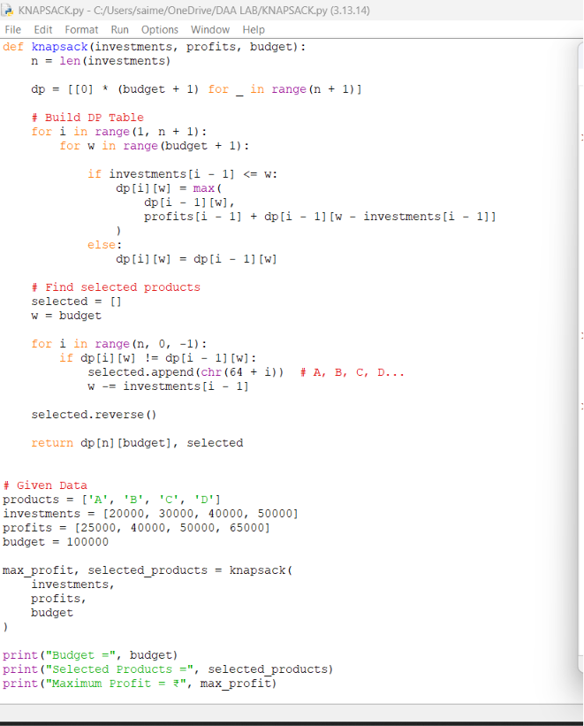

SAMPLE OUTPUT

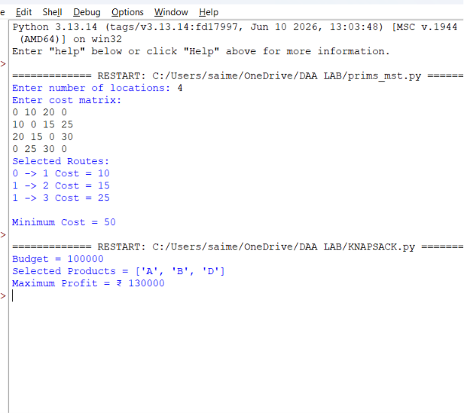
Conclusion
The Manufacturing Resource Allocation problem is modeled as a 0/1 Knapsack Optimization Problem. Dynamic Programming is suitable because it exploits optimal substructure and overlapping subproblems. Using the recurrence relation

Products A, B, and D
with a total investment of ₹100,000 and a maximum profit of ₹130,000. This solution is obtained with Time Complexity O(nW) and Space Complexity O(nW).

